Cairo University Faculty of Computers and Information



**Software Engineering II**

**Software design specification document**

**2019**

**Project Team**

|  |  |  |  |
| --- | --- | --- | --- |
| **ID** | **Name** | **Email** | **Mobile** |
| 20170357 | Ahmed Mohamed Hanafy | ahmedhanfy1111@gmail.com | +201144345627 |
| 20170139 | Abdelrahman Ibrahim Ibrahim | abdelrahman.elbatal19@gmail.com | +201063925141 |
| 20170372 | Ahmed Wessam Fathy | Ahmed.wessam.1999@gmail.com | +201227647347 |
| 20170374 | Omar Khaled Ali | okhaled9@gmail.com | +201118686689 |
|  |  |  |  |
|  |  |  |  |

**Mohamed Hadad – Esraa Salem**

Contents

Class diagram design 2

Sequence diagram design 3

Github repository link 5

# Class diagram design

# 

# Sequence diagram design

1. Login

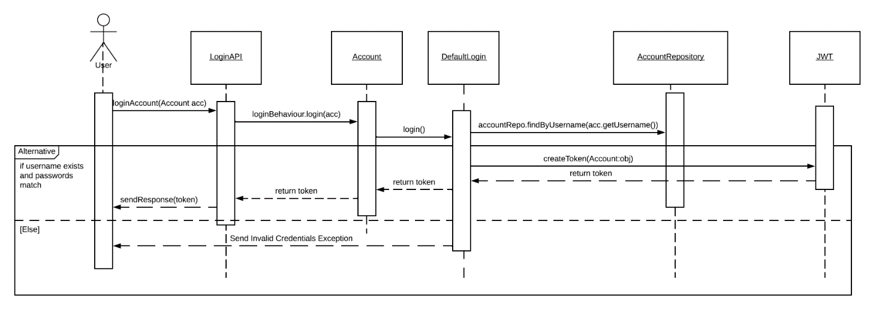

1. **List all registered users**

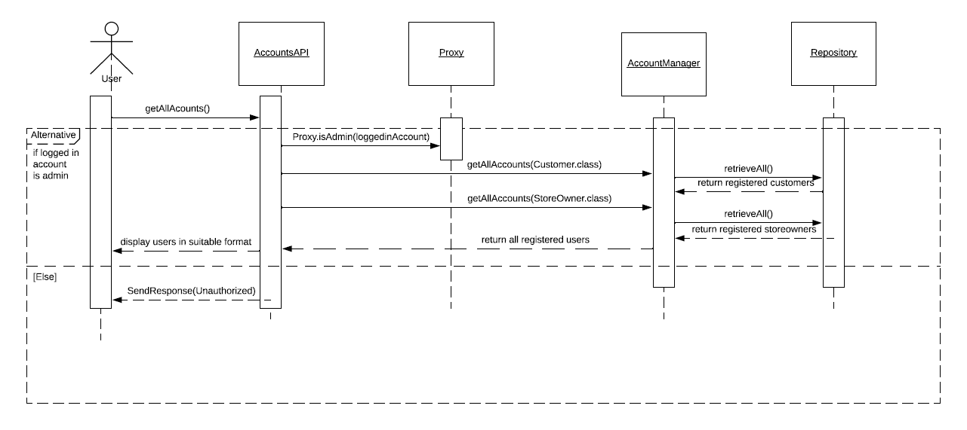

# 

# Github repository link

* <https://github.com/ahmedWessamF/online-shop-api>